**Circuit and System-I**

**LAB # 02**



**Spring 2022**

Submitted by: **Suleman Shah**

Registration No.: **21PWCSE1983**

Class Section: **C**

“On my honor, as student of University of Engineering and Technology, I have neither given nor received unauthorized assistance on this academic work.”

Student Signature: ______________

Submitted to:

**Engr. Faiz Ullah**

14 April 2022

Department of Computer Systems Engineering

University of Engineering and Technology, Peshawar

**ASSESSMENT RUBRICS LAB # 02**

**To find the Resistance of a Resistor by Color code Method**

|  |  |  |  |  |
| --- | --- | --- | --- | --- |
| **LAB REPORT ASSESSMENT** | | | | |
| **Criteria** | **Excellent** | **Average** | **Nil** | **Marks Obtained** |
| 1. **Objectives of Lab** | All objectives of lab are properly covered  [Marks 1] | Objectives of lab are partially covered  [Marks 0.5] | Objectives of lab are not shown  [Marks 0] |  |
| 1. **Resistance and its Units** | Resistance and its units are well defined  [Marks 1] | Resistance and its units, if one of them is missing or partially defined  [Marks 0.5] | Resistance and its units are missing.  [Marks 0] |  |
| 1. **Color Coding Method.** | Define Color Coding Method properly and properly labeled diagram.  [Marks 2] | Color Coding Method is not properly defined and diagram is shown with no labels.  [Marks 1] | Color coding method is not defined and diagram is not shown  [Marks 0] |  |
| 1. **Color Coding Table** | Color coding table is shown with all range of resistances along with their corresponding bands.  [Marks 3] | Color coding table is partially shown with resistances and corresponding bands.  [Marks 1.5] | No color coding table is shown  [Marks 0] |  |
| 1. **Experimental Results** | All experimental results are completely shown in form of table for varying resistors and verification through DMM is also shown.  [Marks 3] | Experimental results are partially shown and some of the observations are missing  [Marks 1.5] | No experimental results are shown  [Marks 0] |  |
| Total Marks Obtained:__________    Instructor Signature: ______________________ | | | | |
|  | | | | |

**Title:**

“To find the resistance of a Resistor by color coding Method”

**Objectives:**

* To find the resistance of resistor by color coding method
* Also using the DMM for resistance measurement

**Resistor:**

A resistor is an electrical component that limits or regulates the flow of current in an electrical circuit. Resistors are very important parts of the circuit, without resistors voltage would be too great for individual components to handle and would result in overloading or destruction. Resistors are mostly made from small rods of ceramic coated with metal. The value of resistance is controlled by the thickness of the coating layer.

**Resistance:**

Resistance is the opposition that a substance offers to the flow of electric current.  It is represented by the uppercase letter R.

Mathematically:

R=V/I

**Unit:**

The standard unit of resistance is the [ohm](https://whatis.techtarget.com/definition/ohm), and sometimes symbolized by the uppercase Greek letter omega: Greek letter omega.

**Ohm (Greek letter omega):**

The SI unit of electrical resistance, transmitting a current of one ampere when subjected to a potential difference of one volt.

**Figure:**

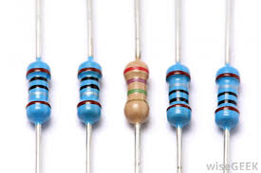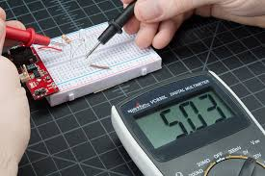

**Color coding Method:**

It is a method in which we used the color bands present on the body of a resistor and find the resistance of that particular resistor the method is known as Color coding method.

Steps to Find the Resistance by Color coding Method:

* The resistor has four or more than four colored bands on its body.
* The first two bands give the values of the resistance.
* The third band is the multiplier in power of ten of the value determined by first two color bands.
* The fourth band gives the tolerance for the resistor.

The color coding of the resistors can be remembered using the following: B B ROY Great Britain Very Good Wife. We will use all upper case letters.

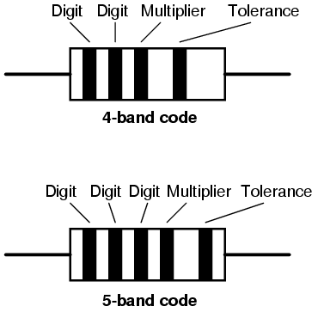Color band Values:

B = Black = 0

B = Brown = 1

R = Red = 2

O = Orange = 3

Y = Yellow =4

G= Green = 5

B= Blue = 6

V= Violet = 7

G = Grey = 8

W = White = 9

Fourth band is either Silver, Gold or no band at all.

Let the color of four bands be Green Red Brown and Silver. Then it's value will be Green = 5, Red = 2, Brown = 10¹ ± Silver = 10%

**Table of color Codes:**

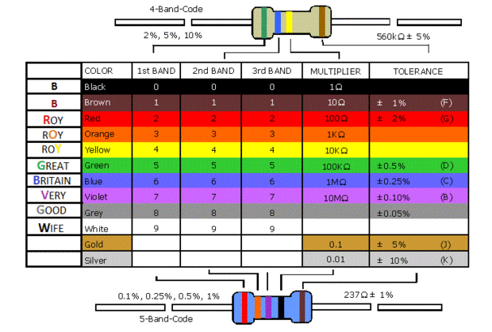

From the color coding table we can find easily the resistance of a given resistor.

**OBSERVATION and calculations:**

|  |  |  |  |  |  |  |
| --- | --- | --- | --- | --- | --- | --- |
| S.NO | 1st Band | 2nd Band | 3rd band | 4th Band | Range | Verification |
| 1 | Brown(1) | Black(0) | Red(102) | Gold(±5%) | 950Greek letter omega-1050Greek letter omega | 982Greek letter omega |
| 2 | Red(2) | Red(2) | Orange(103) | Gold(±5%) | 20900Greek letter omega -23100Greek letter omega | 21 000Greek letter omega |
| 3 | Brown(1) | Black(0) | Green(105) | Gold(±5%) | 950 000Greek letter omega-1 050 000 Greek letter omega | 963 000 Greek letter omega |
| 4 | Brown(1) | Black(0) | Orange(103) | Gold(±5%) | 9500Greek letter omega-10 500 Greek letter omega | 9.3k Greek letter omega |